**PROJECT REPORT**

**Unearthing the environmental impact of human activity: A Global CO2 emission analysis**

1. **INTRODUCTION**
   1. **Overview**

CO2 emissions happens burning of fossil fuels like coal and oil. Coal is responsible for more emissions than any other fossil fuel, representing approximately 41% of global fossil CO2 emissions. The two biggest contributors to global emissions were China and US.

* 1. **Purpose**

The Carbon in CO2 Can be used to produce use today, including methane, methanol, gasoline and fuels that are in aviation fuels.

1. **Problem Definition & Design Thinking**

* 1. **Empathy Map**

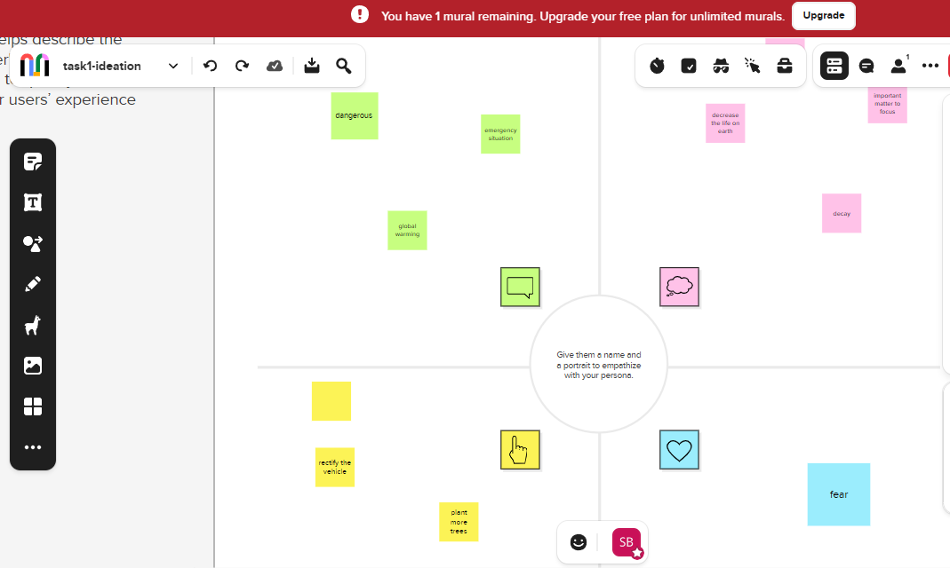

**2.2 Ideation & Brainstorming Map**

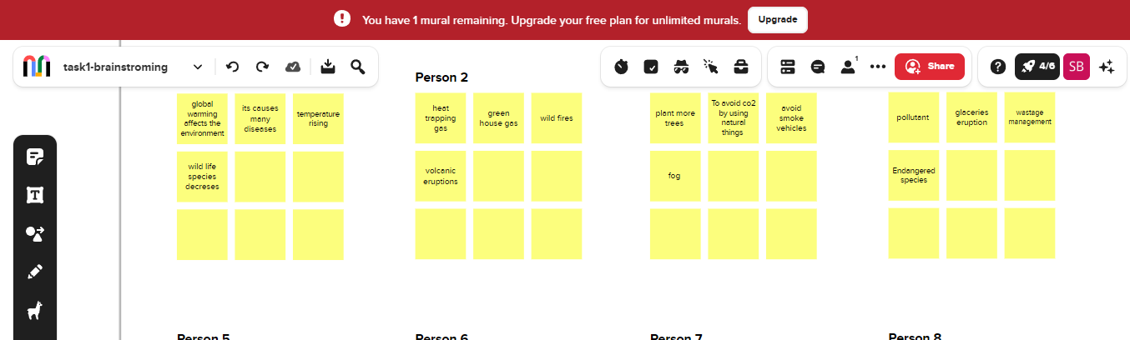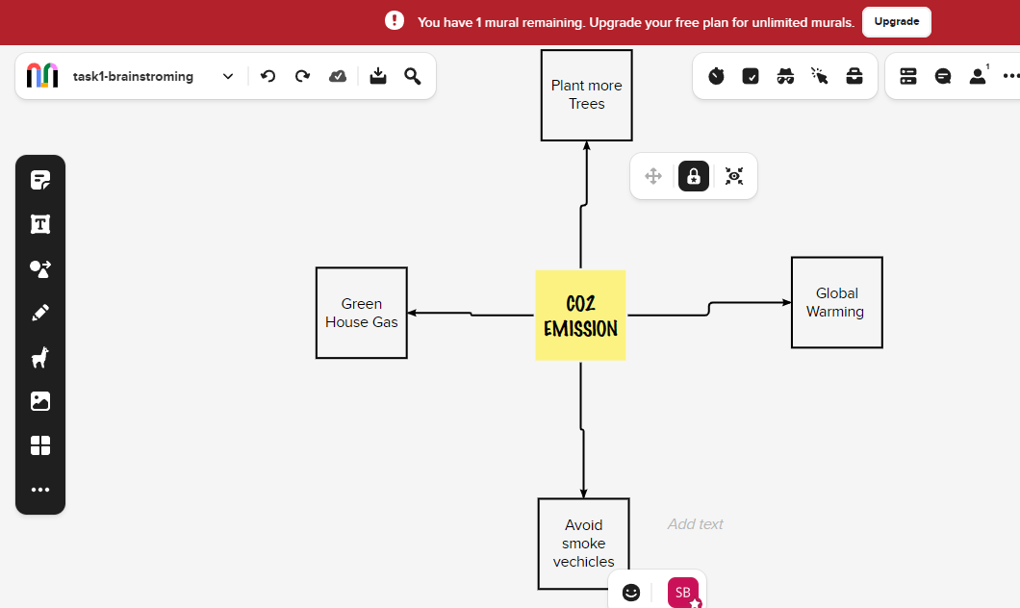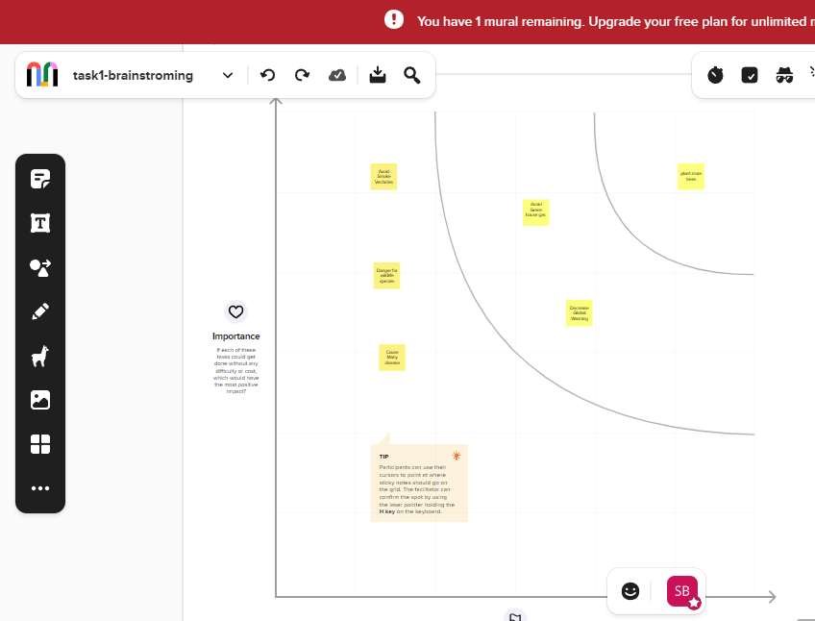

1. **Result**

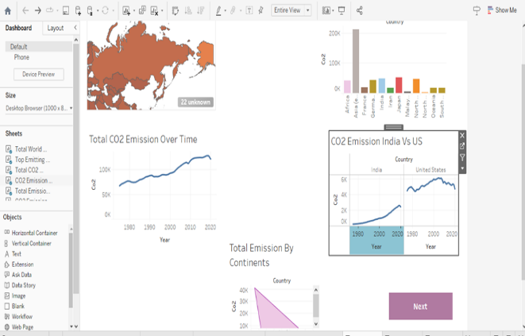 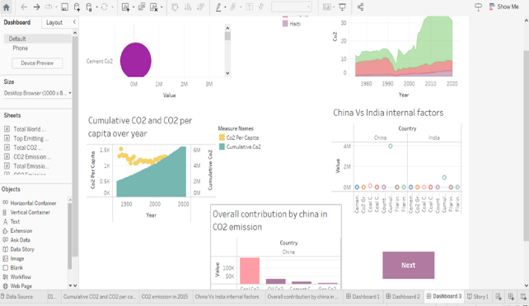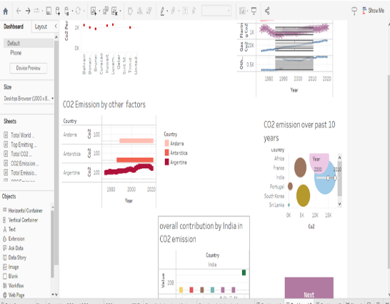

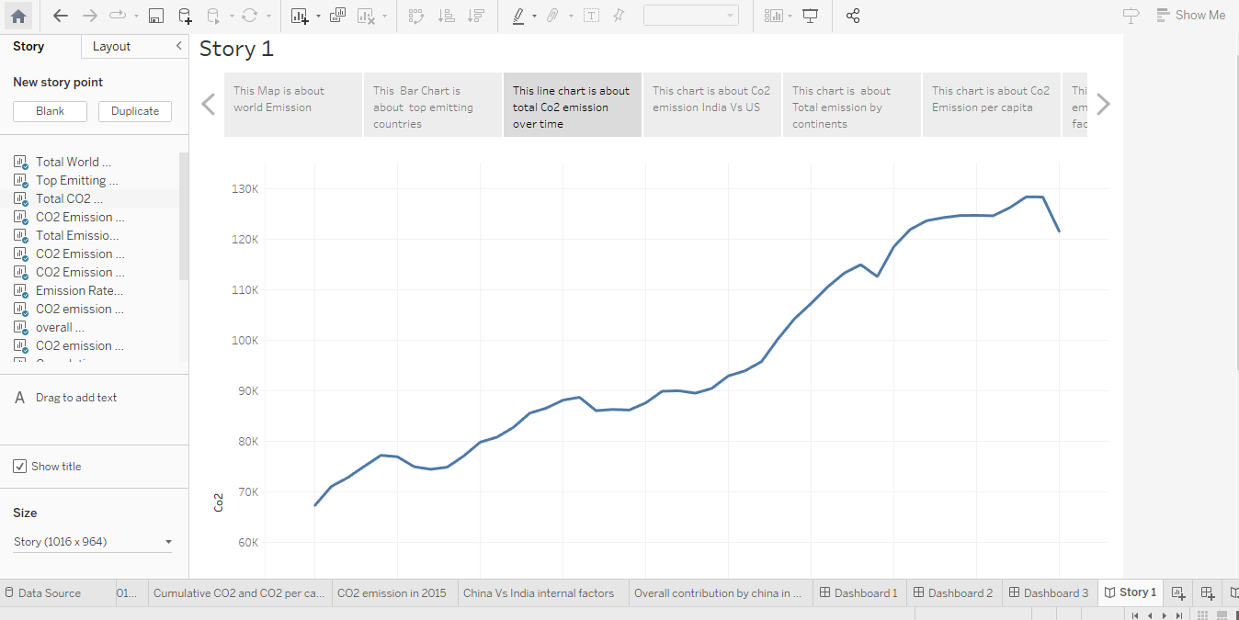

1. **Advantages & Disadvantages**

***Advantages:***

* Green plants grow faster with more CO2.
* More abundant vegetation from increased CO2 is already apparent.

***Disadvantages:***

* + It affects the economic growth & foreign investment
  + It affects the environmental conditions and decrease air quality.

1. **Applications**

The Carbon (and oxygen )in CO2 can be used as an alternative fossil fuels in the production of chemicals, including plastics, fibers and synthetic rubber.

1. **Conclusion**

The rising level of atmospheric CO2 could be the one global natural resource that is progressively increasing food production and total biological output.

1. **Future scope**

In the Annual Energy Outlook 2022(AEO2022) Reference case, which assumes no change to current laws or regulations, the U.S. Energy Information Administration(EIA) project that U.S. energy-related carbon dioxide(CO2) emissions will fail to 4.5 billion metric tons in 2037, or 6% below the energy-related co2..

1. **Appendix**
2. **Source code:** sugapriya team Final project.html